# Bedrock Cross Section Tools

### How to add the toolbox

In ArcPro, find your Catalog pane or view.

Right click on the “Toolboxes” section and select “Add Toolbox”.

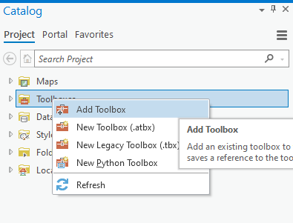

In the box that pops up, navigate to *J:\ArcGIS_scripts\ArcPro\MGS_Bedrock_CrossSectionTools* and click on “MGS Bedrock Cross Section Tools.tbx”. Click OK.

To view the file path for the toolbox **and this document**, hover your cursor over the toolbox in ArcPro. A file path will show in the pop up, which is the same location where this document is stored. You can even directly click the file path and it will open the folder location in windows explorer.

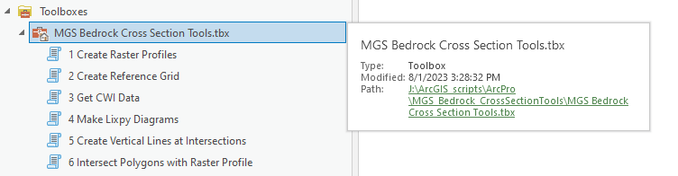

If you would like this toolbox to be added to all new Projects, so **you never have to remember the file path again**: right click on the toolbox in your catalog pane and click “Add to new projects”. Now, the toolbox will automatically add to any new ArcPro project you create. Yahoo!

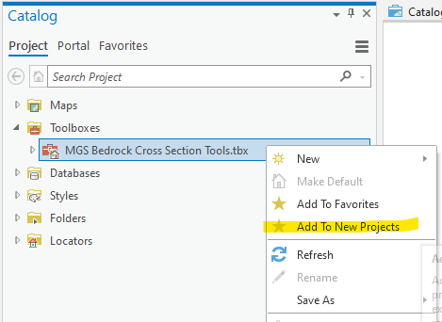

### How do I use the tools?

To use a tool, double click on the name, and parameters will pop up in your geoprocessing pane. For more information about what the tool does, hover your cursor over the blue question mark in the top right corner. For more information about what to put in each of the parameter boxes, hover your cursor over the red asterisk in the top left corner. When you do this, it will turn into a blue “i” and it will give you additional information about the parameter. If there is no red asterisk, move your cursor to the top left corner above the parameter name and a blue “i” will appear. Here is an example in the screenshot below:

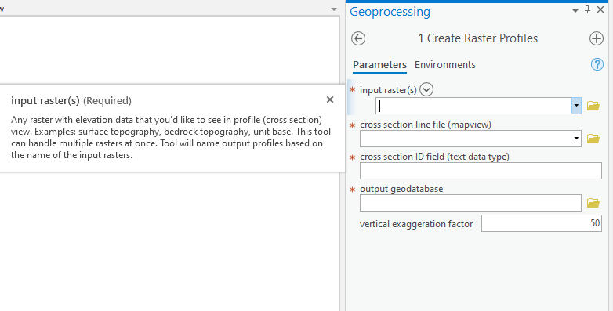

### How do I know which tools I need to run?

You may not need to use every single tool in the toolbox. The tools are numbered in a suggested order, but you may be able to skip tools if you do not need them.

#### 1 Create Raster Profiles

This tool will create profiles along raster surfaces with a vertical exaggeration factor defined by you. You need to run this tool if you would like to view any topography information in cross section view, or if you plan to run the “Intersect Polygons with Raster Profile” tool.

#### 2 Create Reference Grid

This tool will create a background grid that you can use to view elevation and mapview x coordinates in your cross section. Run this tool if you would like to have a background grid.

#### 3 Get CWI Data

This tool will create a well point file and stratigraphy table for wells that are within a buffered area of your cross section lines. Run this tool if you would like to view wells in cross section view. Note that this tool does not *create* the well diagrams; it simply retrieves the data that will be used to create the well diagrams.

#### 4 Make Lixpy Diagrams

This tool uses the output of “Get CWI Data” to create well diagrams in cross section view. (You may need to refresh your geodatabase to get the new files to show up.) It will create 3D lines, 2D lines, and 2D polygons. Run this tool if you would like to view well locations and/or stratigraphy data in cross section view, or if you would like to view CWI wells in a 3D scene.

#### 5 Create Vertical Lines at Intersections

This tool will create a vertical line in cross section view at any location where a point, line, or polygon edge intersects the cross section in mapview. These lines can be used to mark locations, and edited to make more sense for what they are showing. For example: if you use it to mark fault locations, you can edit the line after the fact so the fault only shows in the bedrock, instead of stretching all the way from the top to the bottom of the extent. You could also use it to mark road locations, and then manually create leader pointer lines above the cross section based on the line locations.

#### 6 Intersect Polygons with Raster Profile

This tool will show polygon data along a raster profile. It requires the 3D output from the “Create Raster Profiles” tool. It will create line segments along the raster profile as well as points at polygon boundaries.

### How do I set up my data to view one cross section line at a time?

By default, the tools will create one file, regardless of how many cross section lines you have. If your mapview cross sections have multiple lines, you will need to use a definition query to view data from one line at a time. To do this, right click the layer and go to “properties” (or simply double click the layer). Next, find the definition query option. Click “New definition query” and use the drop-down menus to write your query. Click “Apply” and “OK”.

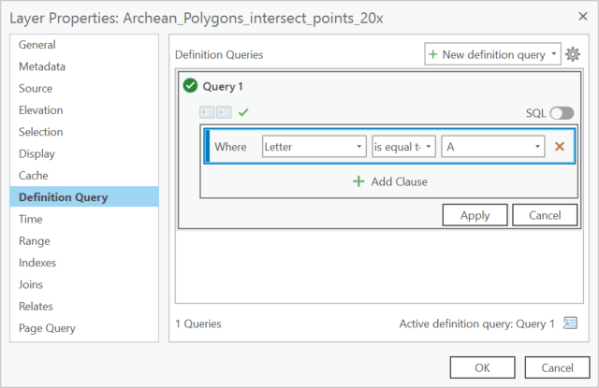

You will need to make multiple copies of each layer with different definition queries to view each line. I suggest making a group layer for each cross section line, and adding all of the data you need for each line to the group.

### How do I symbolize my data?

Symbology choices are up to you. However, I have created layer files to make the grid symbology a little easier. Right click on either your elevation or x coordinate grid layer and click “Symbology” to open the grid. Click the menu in the top right corner and select “Import Symbology”:

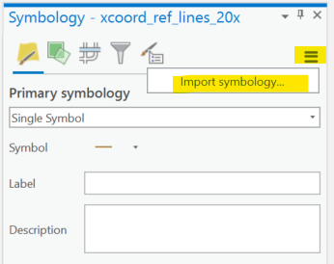

The geoprocessing tool “Apply Symbology from Layer” will open. Under “Symbology Layer”, click the folder icon and navigate to *J:\ArcGIS_scripts\ArcPro\MGS_Bedrock_CrossSectionTools\Symbology*. Select the grid layer file in either light mode or dark mode. The rest of the parameters should populate automatically. Click OK, and then click “Run” at the bottom.

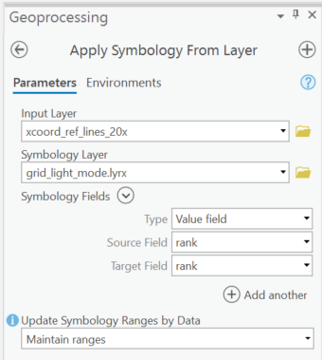

The process is the same for both the x coordinate reference lines and elevation reference lines. The same layer file will work for both. The layer file will make major gridlines more prominent than minor gridlines, and will add labels to major gridlines.

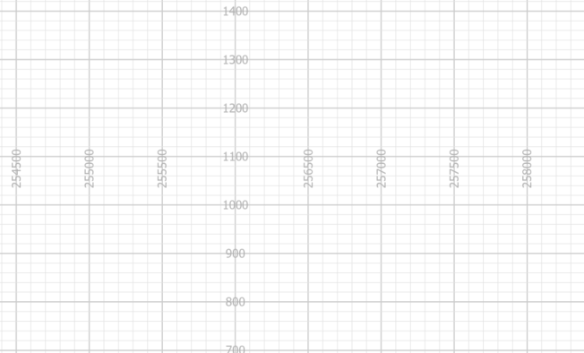

### What if I get an error?

Errors will happen. If the box at the bottom of your geoprocessing pane turns red, click “view details”. A box will pop up with more information. Click on the “Messages” tab to find the error. If you understand how to fix it, go ahead and do that. If you do not understand how to fix it, take a screenshot of the error and send it to the GIS staff for help.